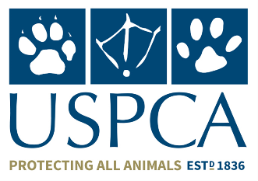
Thank you for your interest in volunteering for USPCA. Please complete this short form and return it USPCA, Unit 5 & 6 Carnbane Industrial Estate, Newry, Co Down BT35 6QH or email: headoffice@uspca.co.uk
The information you provide is strictly confidential and we will use it to administer any volunteering you do with us. We welcome applications from people of all abilities, backgrounds and communities.
About You
Full Name

Address

Postcode

Email

Telephone

Mobile

Role Appling for: ___________________________________________________________________
How did you hear about the Role: ____________________________________________________
My current Employment Status: _____________________________________________________
i.e. (Retired, Student, Employed, Unemployed)
My Interests, Experience & Skills I can bring to the Role:

Your Availability: Please tick as appropriate
DAY | Monday | Tuesday | Wednesday | Thursday | Friday | Saturday
AM
PM

Referees
(Examples could include: a previous manager, support worker, landlord, tutor or another volunteer)

Full Name: | Full Name:
Address: | Address:
Telephone: | Telephone:
Email: | Email:
Relationship: | Relationship:

I confirm that the details I have given are correct:

Signed: ________________________________________________ Date_____________________
__________________________________________________________________________________
Staying in touch
We would like to keep in contact with you with updates about our work.

By Post By Email By Text (Please Tick)

Signature: __________________________________ Date: ____________________

